**Angular 6**

1. What is Angular

Angular is a JavaScript framework which allows you to create reactive single page application(SPAs).

1. Project set up using CLI
   1. npm install –g @angular/cli
   2. ng new my-first-app
   3. ng serve (localhoat:4200)
2. Basic Project set up using bootstrap for styling
   1. npm install –save bootstrap@3
   2. open angular.json and edit the styles tag

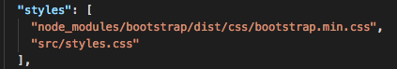

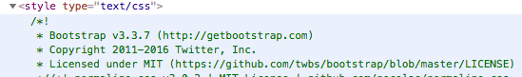

1. How Angular gets loaded and started
   1. main.ts bootstrap the AppModule, app.module.ts registers the AppComponent, app.component.ts gets the output generated and app.component.html renders the view (index.html).

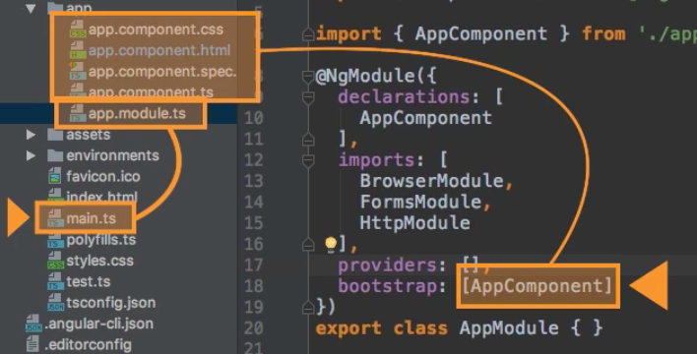

1. Create a Component Manually
   1. Create folder structure with files (server component)

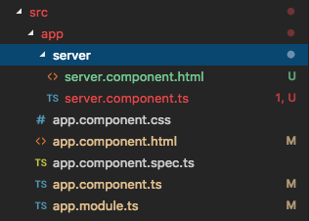

* 1. Create component in the ts file

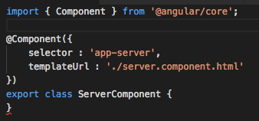

* 1. Register component in app.module.ts

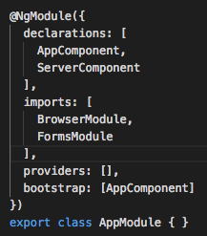

* 1. Update the server html file to render the view

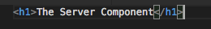

* 1. Output the value in app component html.

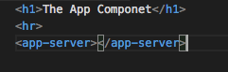

1. Creating component with CLI
   1. ng generate component servers
   2. ng g c servers
2. Component Selector various form
   1. Element selector



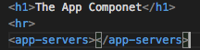

* 1. Attribute selector



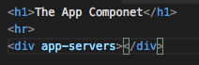

* 1. Class selector



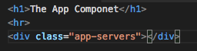

1. Data Binding
   1. String Interpolation
   2. Property Binding
   3. Event Binding

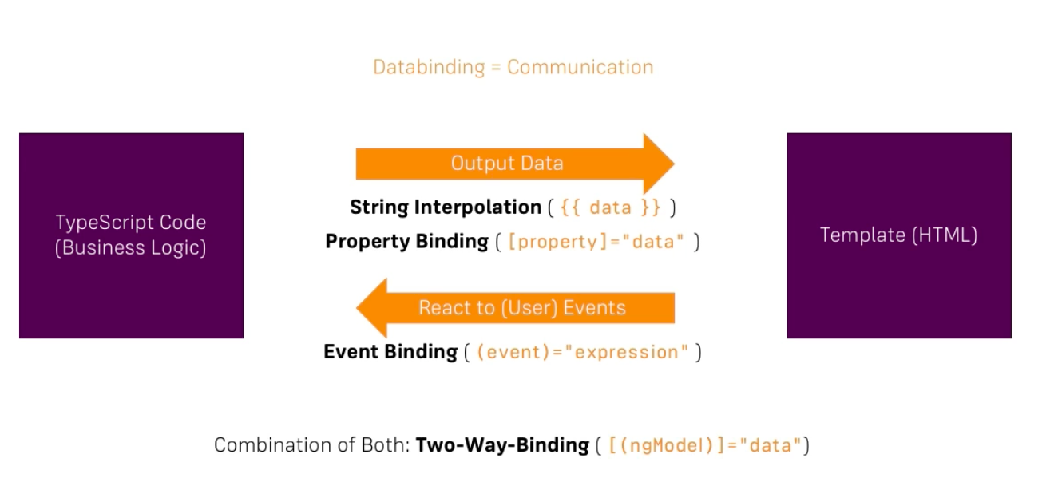

1. String Interpolation
   1. When you want to output something in view use string interpolation.

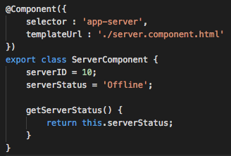



1. Property Binding
   1. if you want to change property of an html elements use property binding.



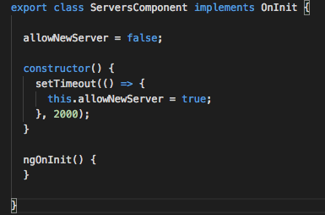

1. Events Binding
   1. click event is added.
   2. When add server button is clicked, it changes the status.



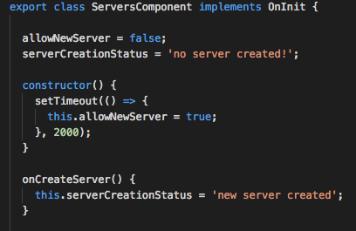

1. Event Binding to pass input into the ts file

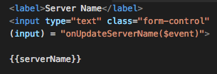

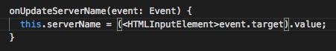

1. Two Way Data Binding
   1. For Two-Way-Binding to work, you need to enable the ngModel directive. This is done by adding the FormsModule to the imports [] array in the AppModule.
   2. Here we combine property and event binding

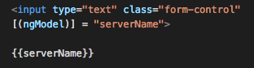

1. Directives
   1. Directives are the instructions in the DOM
   2. Built-in directives
   3. Custom directives
2. ngIF and ngElse
   1. This is a built in structural directive.
   2. set the serverCreated value and ngIf will work accordingly.

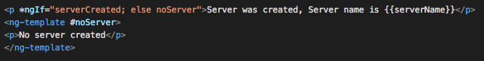

1. nfFor
   1. create an array of servers
   2. push the server name in code.
   3. To retrieve use the below code.



1. Attribute directives
   1. Unlike structural directive, attribute directives don’t add or remove elements. They only change the elements they are placed on.
   2. ngStyle: it allows to dynamically change the css.

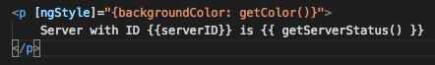

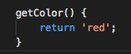

* 1. ngClass: it allows to dynamically add or remove css classes.

1. Debug Angular using chrome browser
   1. goto the source tab

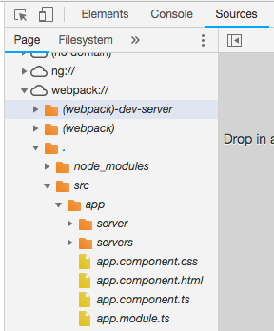

1. Augury: tool to understand the angular application.
   1. Comes with chrome extension
2. Component Communication
   1. In Angular a component can share data and information with another component by passing data or events.
   2. A component can be used inside another component, thus creating a component hierarchy.
   3. The component being used inside another component is known as the child component and the enclosing component is known as the parent component.
   4. Components can communicate to each other in various ways, including:
      1. Using @Input()
      2. Using @Output()
      3. Using Services
      4. Parent component calling ViewChild
      5. Parent interacting with child using a local variable
3. Component Communication using @Input()
   1. @Input decorator or input properties are used to pass data from parent to child component
   2. Create a child component which will be used inside another component.
   3. In the child component, we have decorated the greetMessage property with the @Input() decorator so that value of greetMessage property can be set from the parent component.

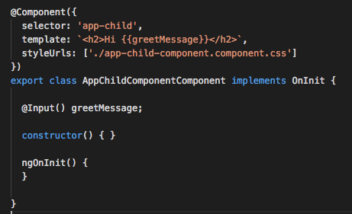

* 1. From the parent component, we are setting the value of the child component’s property greetMessage.
  2. To pass a value to the child component, we need to pass the child component property inside a square bracket and set its value to any property of parent component.
  3. We are passing the value of childmessage property from the parent component to the greetMessage property of the child component.

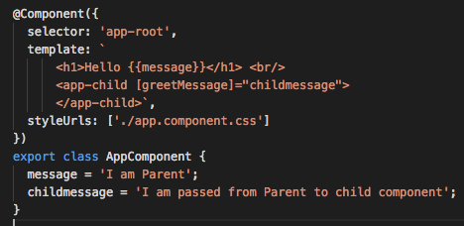

1. Component Communication using @Output()
   1. if you want to execute a function of **AppComponent** on the click event of a button inside **AppChildComponent**
   2. To do this, you will have to emit the button click event from **AppChildComponent**.
   3. Import **EventEmitter** and **Output** from **@angular/core**.

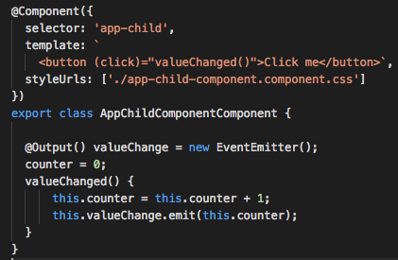

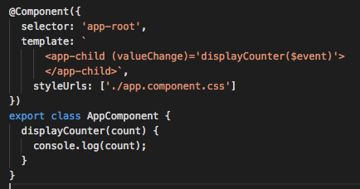

1. View Encapsulation in Angular
   1. To understand **ViewEncapsulation** in Angular, first, we should understand the **Shadow DOM.**
   2. The Shadow DOM brings **Encapsulation** to HTML Elements. Using the Shadow DOM, markup, styles, and behaviors are scoped to the element and do not clash with other nodes of the DOM.
   3. To emulate the Shadow DOM and encapsulate styles, Angular provides their types of View Encapsulation. They are as follows:
      1. Emulated
      2. Native
      3. None
   4. Adding CSS in app.component.css and no CSS in child component.

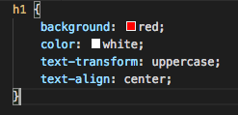

* 1. Child component

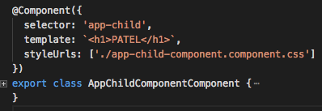

* 1. When the encapsulation is NONE
     1. There will be no shadow DOM. You will find h1 style will be applied to both the components even though we have set the style in app component only.

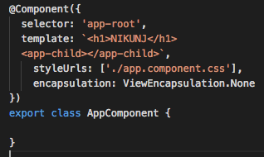

* 1. When the encapsulation is EMULATED only main component will be applied with the style.
  2. When the encapsulation is NATIVE You will find h1 style will be applied to both the components even though we have set the style in app component only.

1. Using local reference in Template
   1. Here, whole element is sent using the local reference.

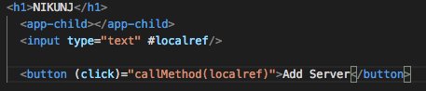

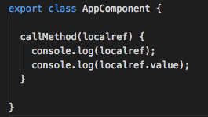

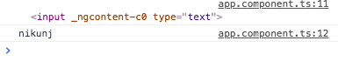

1. @ViewChild
   1. in order to access the variable locally or in any template we can use this annotation.

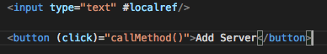

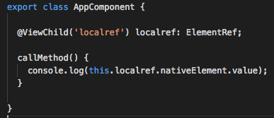

1. Component Life Cycle

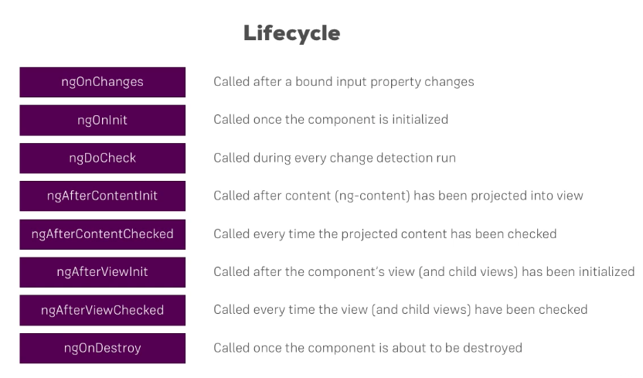

1. Creating a basic attribute directive
   1. this directive changes the color wherever placed.

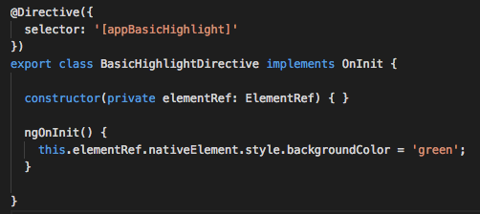



1. Using Renderer to build a better attribute directive.

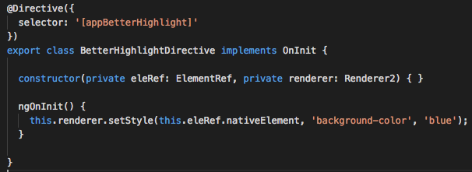

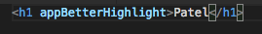

1. Using HostListner for reacting to events.
   1. If mouse is hover on the text, it will change color.



1. ngSwitch Directive

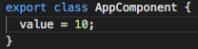

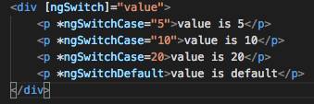

1. Creating a Logging Services and Dependency Injection.
   1. Create a logging.service.ts class (this class will have injected all over the components which logs the data.)

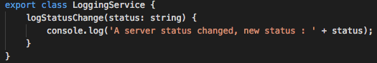

* 1. In order to inject the service, provide the provider tag in the component and constructor to inject the service.

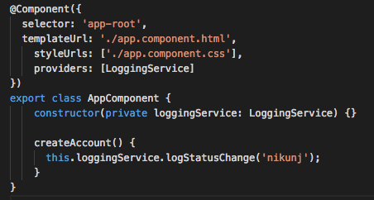

1. Injecting Service into Service (@Injectable)
   1. in app.module.ts, update both the service in the provider

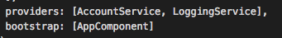

* 1. create independent service which needs to be injected.

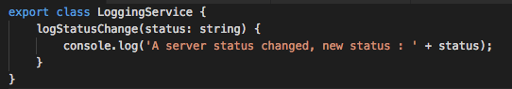

* 1. Create a service, where we will be injecting the above service

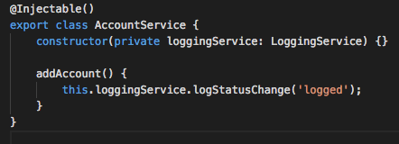

* 1. Create the main component.

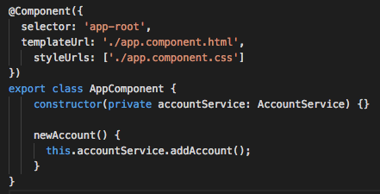

* 1. Call the service from the view.



1. Setting up and loading Routes.
   1. Register the Routes in the AppComponent.



* 1. UI rendering



* 1. In order to switch between URL, the active tab can be show accordingly.
     1. For the / path, we need to configure the exact match.

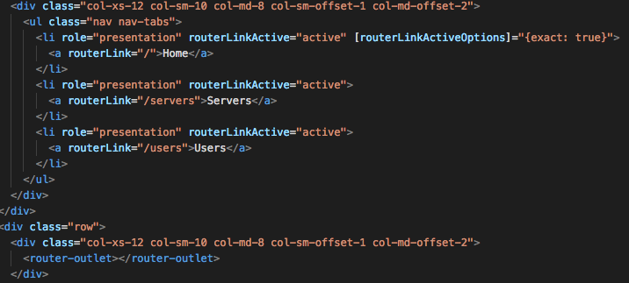

* 1. Navigating Programmatically
     1. Suppose we want to navigate Programmatically from one component to another using route.



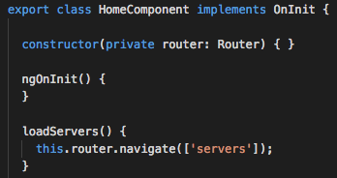

* 1. Passing Parameters to the route and fetching the data.
     1. Register the route and parameters in the main component.



* + 1. Get the value in the component.

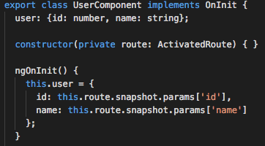

* + 1. Render in the html.

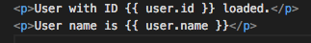

* 1. Fetching routes parameters reactively.
     1. If you are in a component, and if you know that the parameters in the same component changes, angular does not reload the page as its already in the same component.
     2. In order to load the new change, we use **observable** which loads the new param in the same component.



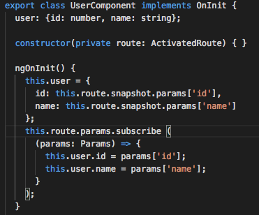

* 1. Passing query parameters and fragments.

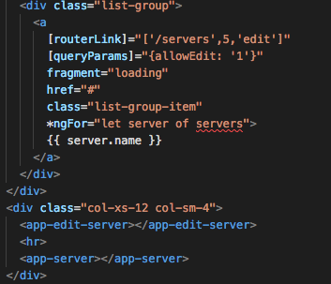



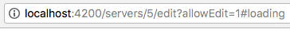

* 1. Passing query parameters and fragments programmatically



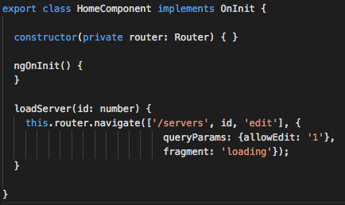

1. What is Observable
   1. Observables open the continuous channel of communication where multiple values are emitted over time.
   2. It a 3rd party library rxjs.
   3. In a real-world example, we can say that the Internet service offered to mobile devices is an observable. It is available only to the people who have subscribed to it. We continuously receive this service from the service provider only as long as this service is on and we are subscribed to it.
2. Creating simple observable
   1. This example emits number in a fixed interval and also unsubscribed when moved to another component.
   2. In general, you can pass 3 arguments to subscribe.
      1. Call back for handling normal data
      2. Call back for handling errors
      3. Call back for completion

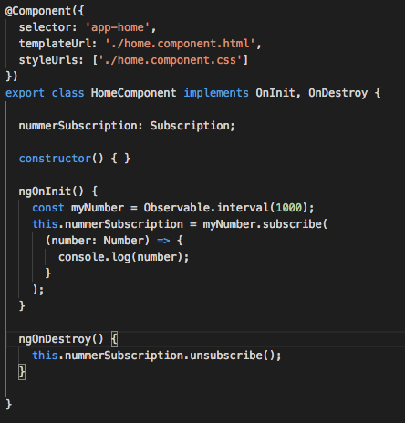

1. Forms in Angular
   1. Template Driven
      1. Angular infers the form object from the DOM
      2. Use ngModel and name attribute in the input tags
   2. Reactive: form is created programmatically and synchronized with the DOM.
2. Template Driven
   1. Form creation







* 1. Another way for form submission (@ViewChild)



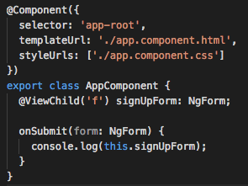

* 1. Validating form
     1. disable the submit button



* + 1. Apply CSS if the entered value is wrong

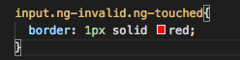

* + 1. Outputting the validation error messages.

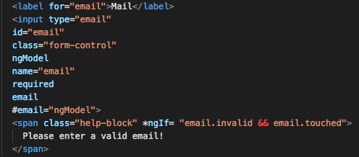

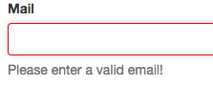

1. Reactive Approach
   1. Here form is created programmatically in the typescript.
2. Pipes: Transforms output in the template before rendering.
   1. ng g p pipe-name



1. Custom Pipes
   1. Create a pipe

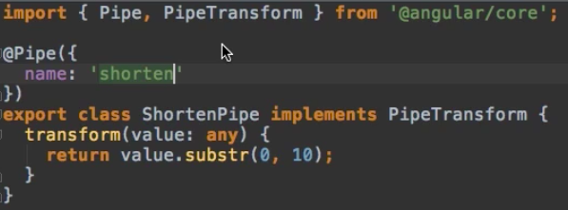

* 1. Import into declaration

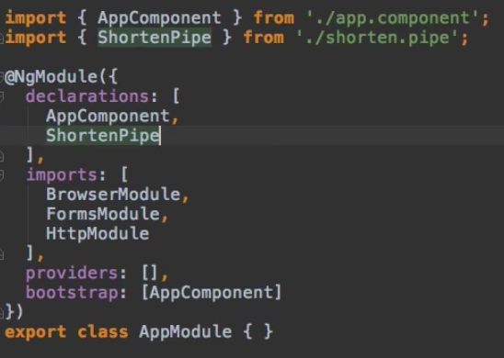

* 1. Apply in HTML

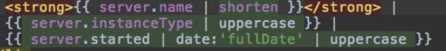

1. Sending HTTP Request
   1. create a service get and post (configured a real time database in firebase)

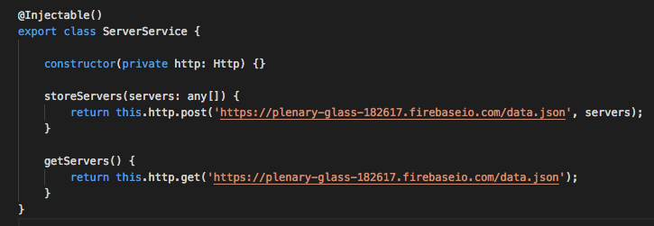

* 1. register in the app module
  2. create a method which calls this service. Get request has a json response which can be converted into JavaScript object using json () method.

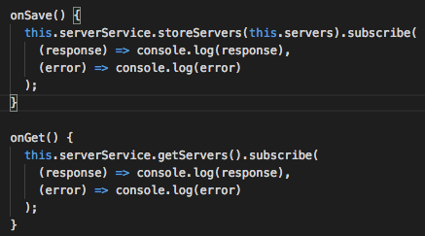

* 1. create a view which calls

